Volume: N, Issue: n  Page: 01-00  YEAR | ISSN 00-00 (Online) & ISSN 00-00 (Print)  International Journal of Academic Research in Business, Arts and Science (IJARBAS.COM)

Title of your Manuscript

(Font: Cambria, size: 26, Bold)

Author1, Author2,..... & AuthorN

(Font: Cambria, Size: 13, Bold)

Abstract: (Font: Cambria, Size: 13, Bold)  Your abstract here  (Font: Cambria, Size: 13, Line Spacing: 1) | 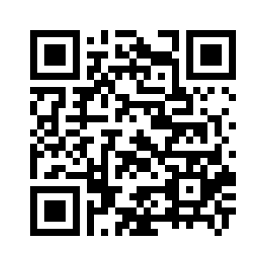  IJARBAS  Accepted 07 September 2019  Published 09 September 2019  DOI: After_final_publication

Keywords: 5- 8 keywords (Font: Cambria, Size: 11-13, Line Spacing: 1)

Author1, Designation, Organization, Location, Country
Author2 (Corresponding Author) Designation, Organization, Location, Country
Author3, Designation, Organization, Location, Country

About Author

Introduction (All heading - Font: Cambria, Size: 12, Bold)
(All Description: Font: Cambria, Size: 12, Line Spacing: 1)

• Citation in Text:
Journal and book articles should be referred by the authors name and year of publication e.g. ( Smith and Ward, 2000 ).
*For more than 2 authors, use following structure: ( Smith et al., 2000 ).
*For more than 2 references, use following structure: ( Smith et al., 2000; Ward, 2004; Jackson, 2008 )

References

• Journal:
Lee, S. A., Johnson, T.S., Ward, J. P. and Jackson, S. ( 2000 ). Comparative Study of 3 Management Methods. International Journal of Science and Business, 36 ( 4 ), pp. 232- 245.
* The name of the journal should be typed in italic style.
•Book:
Bennet, A., Ward, R.A. and Lee, A.P. ( 2002 ). Applied Management Models, chapter ( 3 ), Vol.: 2, 2nd ed. London: Oxford University Press, pp.63-74.
* The name of the book should be typed in italic style.
•Website:
Smith, J. A. (2002). Business Solutions. Available: http:/www.hoovers.com/hooversdirectoies/ companiesaz-1.htm ( August 8, 2002 ).
•Theses and Dissertations:
Terner, John. Comparative Study of Two International Marketing Models, Ph.D. dissertation, University of Florida, 2003, pp. 26-40.

Cite this article:
Author1, ....... & AuthorN (Year). Name of the article. International Journal of Academic Research in Business, Arts and Science, n(n), 01-00. doi: https://doi.org/After_Final_Publication
Retrieved from http://ijarbas.com/wp-content/uploads/office.pdf

Published by

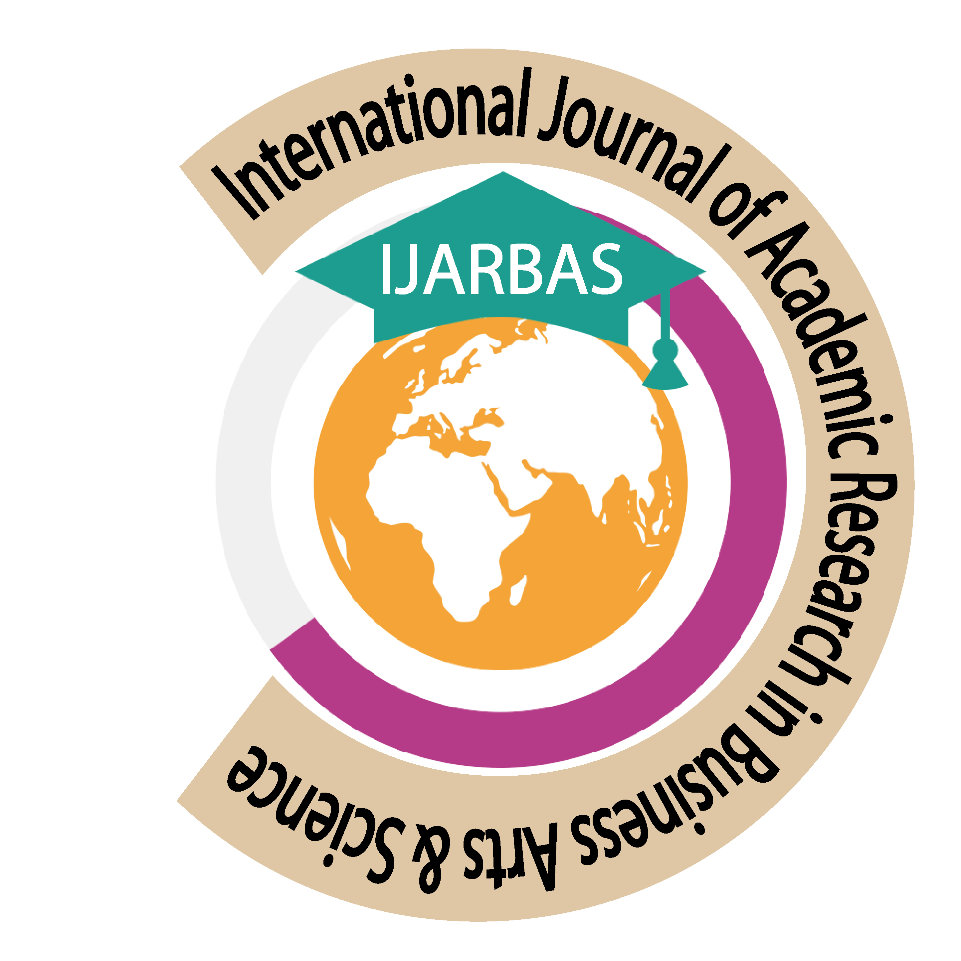 | 

Guideline – Authors Info:
Please visit: https://www.ijarbas.com/authors-info/

Corresponding author may also send doc file of article, our editorial office will edit that file in our template

Current review Time: 4 days
Correction Time: 5 days

